
Lesson 15: Ready to Show
Scratch
VIDEO GAME CREATION
Today has no new code to build. It's a workshop day: polish what's roughest, then present your finished capstone game to the class. This is the Level 3 Refined milestone - the end of Semester 1's build.
Open your own [YourName]Game project from Lesson 14 - this IS your capstone. There's nothing separate to submit.

Your Full Capstone Checklist
Work through this checklist first. Anything unchecked is your polish-time priority - fix these before adding anything new.
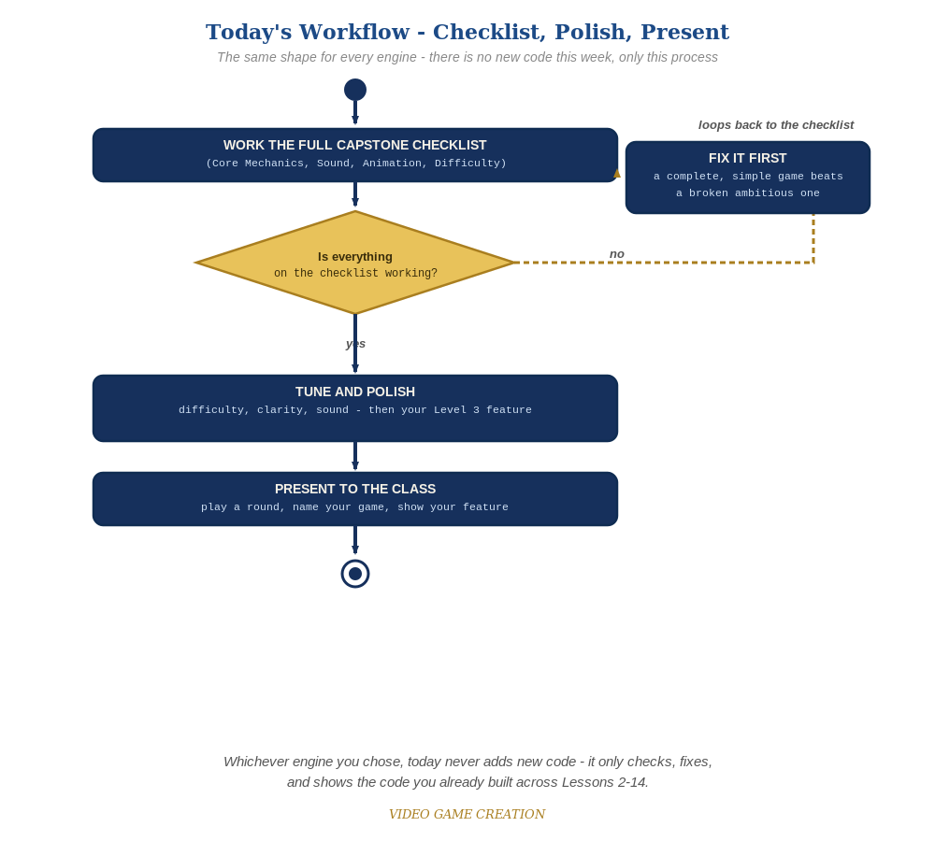
Today never adds new code - the same checklist-polish-present loop applies no matter which engine you chose.

Core Mechanics (Lessons 2-11)
- Move and shoot respond correctly to input, every time.
- Enemies are destroyed on hit, and score increases correctly.
- An enemy escaping unshot costs a life, and lives are tracked correctly.
- Score, lives, and wave are all shown clearly on screen at all times.
- Winning and losing both work, and both show a clear message with a restart hint.
- Pressing R restarts cleanly from any state - mid-round, after a win, or after a loss - back to wave 1.
- Multiple waves work correctly: clearing a non-final wave spawns a fresh one; only the final wave triggers a real win.

Sound (Lesson 12)
- A shot makes a sound.
- A hit/explosion makes a sound.
- A wave clear makes a sound, distinct from the win sound.
- A game over makes a sound.

Animation (Lesson 13)
- A hit briefly flashes the enemy before it's removed.
- An independent explosion effect appears and cleans itself up on every hit.

Difficulty (Lesson 14)
- Enemy count increases with each wave.
- Enemy speed increases with each wave.
- Your chosen Level 3 stretch feature is present in at least a rough, good-faith form.

Polish Pass
With whatever time remains after the checklist above, work top to bottom through these polish priorities - in order:
- Fix anything broken or unchecked above first - a complete, working Level 1/2 game beats a flashy but broken one.
- Tune anything that feels unfair or confusing - difficulty too easy/hard, unclear on-screen text, a sound that's too loud or jarring.
- Only after 1 and 2: continue building out your Lesson 14 stretch feature, or add a small extra touch if you have time and energy left.
- Common Scratch rough edges to check: variables not set to "for all sprites" when they should be, a stray "forever" loop left in the wrong script, or a costume left in the wrong state after cloning.

Preparing Your Presentation
Presentations are short - about 2 minutes each. You don't need slides or notes; just be ready to talk while you play. A simple structure that works well:
- Name your game and describe its core mechanic in one sentence.
- Play a short round - enough to show a hit, a wave clear, and either a win or a loss.
- Point out your chosen Level 3 stretch feature specifically, even if it's not fully finished.
- If something breaks live, that's genuinely fine - briefly say what it's supposed to do and move on. A confident presentation matters more than a perfect one.

Want More?
Student Resource List > Scratch section, or scratch.mit.edu/ideas

